DSA02- COMPUTER VISION WITH OPENCV
ASSIGNMENT
A. Assignment Information
Department: | AI & DS
Programme: | FACULTY OF ENGINEERING
Course Code & Course Name | DSA02- COMPUTER VISION WITH OPENCV
Academic Year / Batch | 2026-2027
Faculty Name | Dr. G. A. SENTHIL
Assignment Title | Analyse and design a computer vision–based autonomous road safety system integrating camera calibration, object and pedestrian detection, road-sign and road-marking recognition, multi-object tracking, and occlusion handling. Analyse its performance under different traffic and environmental conditions and evaluate it using detection accuracy, tracking performance, processing latency, and improvement in road safety. Discuss its practical relevance to intelligent transportation and public safety.
Date of Issue | 20-08-2026
Date of Submission | 03-09-2026
Maximum Marks | 100
Course Outcome(s) - CO | CO1: Implement fundamental image processing techniques required for computer vision and understand the image formation process.  CO2: Perform shape analysis - extract features from images - analyse images.  CO3: Generate 3D models from images.  CO4: Develop applications using computer vision techniques.  CO5: Understand video processing - motion computation - 3D vision - geometry.
Bloom's Taxonomy Level | . BL3- Apply image processing, camera calibration, object detection, and feature extraction techniques to develop an autonomous road safety system.  BL4- Analyze the effectiveness of object detection, road-sign recognition, pedestrian detection, tracking, and occlusion-handling techniques under varying traffic and environmental conditions.  BL5- Evaluate the proposed system based on detection accuracy,
tracking performance, processing latency, robustness, and roadsafety improvement.
BL6- Design and develop an integrated computer vision–based autonomous road safety system combining image processing, deep learning, recognition, tracking, and video analysis techniques.
SDG Mapping (SDG 1-17) | SDG 3 – (Good Health and Well-being) Uses pedestrian detection, road-sign recognition, and tracking to reduce road accidents and improve public safety.  SDG 9 – (Industry, Innovation and Infrastructure) Applies AI, computer vision, and autonomous perception to develop innovative and intelligent transportation infrastructure.  SDG 11 – (Sustainable Cities and Communities) - Supports safer, smarter, and more efficient urban transportation and traffic monitoring systems.  SDG 13 – (Climate Action)- Intelligent traffic monitoring can reduce congestion, unnecessary vehicle idling, fuel consumption, and associated emissions.
Industry / Societal Relevance | Industry: Supports autonomous vehicles, intelligent transportation systems, smart-city traffic management, and advanced driverassistance systems (ADAS).  Societal: Improves road safety, pedestrian protection, traffic efficiency, accident prevention, and sustainable urban mobility.

Assignment Question
Analyse and design a computer vision–based autonomous road safety system integrating camera calibration, object and pedestrian detection, road-sign and road-marking recognition, multi-object tracking, and occlusion handling. Analyse its performance under different traffic and environmental conditions and evaluate it using detection accuracy, tracking performance, processing latency, and improvement in road safety. Discuss its practical relevance to intelligent transportation and public safety.

- Problem Statement and Problem Formulation
Road accidents are commonly caused by delayed driver reaction, poor visibility, pedestrian crossings, violation or misinterpretation of road signs, lane departure, and failure to identify nearby vehicles or obstacles. Human drivers may find it difficult to continuously observe every object surrounding a vehicle, particularly in dense traffic, low-light conditions, rain, fog, or when objects are partially hidden.
The proposed project aims to design a Computer Vision–Based Autonomous Road Safety System capable of continuously analyzing road video captured using a camera mounted on a vehicle.

The system integrates:
- Camera calibration
- Vehicle and object detection
- Pedestrian detection
- Traffic-sign recognition
- Road-marking and lane detection
- Multi-object tracking
- Occlusion handling
- Safety-alert generation

The main problem can be formulated as follows:

Given a sequence of road images or video frames (F_1, F_2, ..., F_n), the system must identify safety-critical objects, determine their locations, assign consistent tracking identities, recognize road signs and markings, and generate warnings when potentially dangerous situations are detected.
The final system should perform these operations with high accuracy while maintaining sufficiently low processing latency for near-real-time road-safety applications.

- Objective and Expected Outcomes
Objectives
The major objective of the project is to develop an integrated computer-vision system that improves road safety by automatically analyzing traffic scenes.

The specific objectives are:
- To calibrate the road-facing camera and minimize lens distortion.
- To detect vehicles, pedestrians, bicycles, motorcycles, traffic lights and other road objects using YOLO.
- To recognize important traffic signs such as Stop, Speed Limit, No Entry and Pedestrian Crossing signs.
- To detect lane boundaries and important road markings using OpenCV.
- To track multiple moving vehicles and pedestrians using ByteTrack.
- To maintain object identities even when temporary occlusion occurs.
- To analyze the system under normal traffic, dense traffic, night conditions, rain and partial occlusion.
- To evaluate the system using detection accuracy, tracking performance and processing latency.
- To generate safety warnings for dangerous objects or situations.
- To demonstrate the usefulness of computer vision in Intelligent Transportation Systems and Advanced Driver Assistance Systems.

Expected Outcomes
The proposed system is expected to:
- Detect multiple road users simultaneously.
- Identify pedestrians with good accuracy.
- Recognize important traffic signs.
- Detect lane boundaries.
- Track moving vehicles using unique IDs.
- Recover tracks after short-term occlusion.
- Provide visual alerts for potential hazards.
- Process road videos with acceptable latency.
- Improve situational awareness and reduce potential accident risks.

- Requirements, Constraints and Assumptions
Hardware Requirements
- Laptop/Desktop computer
- Minimum 8 GB RAM recommended
- Webcam or vehicle-mounted camera
- Internet connection for Google Colab
- GPU-enabled system or Google Colab GPU recommended

Software Requirements
- Python 3.x
- Google Colab
- OpenCV
- PyTorch
- YOLO
- NumPy
- Matplotlib
- ByteTrack
- Pandas

Input Requirements
The system accepts:
- Road video
- Dash-camera footage
- CCTV traffic footage
- Recorded road-scene videos
- Individual road images

Constraints
Several factors can reduce system performance:
- Poor illumination
- Heavy rain
- Fog
- Motion blur
- Camera vibration
- Small distant objects
- Overlapping vehicles
- Pedestrian occlusion
- Damaged traffic signs
- Faded lane markings
- High computational requirements of deep-learning models

Assumptions
The following assumptions are considered during implementation:
- The camera is mounted in a stable forward-facing position.
- Road objects are reasonably visible.
- The camera provides sufficient image resolution.
- The YOLO model contains classes relevant to traffic environments.
- Lane markings are at least partially visible.
- Temporary occlusion lasts only for a limited number of frames.
- Processing is performed using a GPU whenever available.

- Application of Relevant Course Knowledge / Concepts
The project combines several important Computer Vision concepts.

4.1 Image Acquisition
Video frames are continuously captured from a camera or road video.
Each video is represented as a sequence of frames:
[
Video = {F_1,F_2,F_3,...,F_n}
]
Each frame is independently processed and also compared with previous frames for tracking.

4.2 Camera Calibration
Camera calibration determines camera parameters and removes lens distortion.
The calibration process estimates:
- Camera intrinsic matrix
- Focal length
- Principal point
- Lens distortion coefficients
A chessboard calibration pattern can be used.
The intrinsic camera matrix can be represented as:
[
K =
\begin{bmatrix}
f_x & 0 & c_x\
0 & f_y & c_y\
0 & 0 & 1
\end{bmatrix}
]
where:
- (f_x, f_y) = focal lengths
- (c_x, c_y) = optical center coordinates
OpenCV functions such as cv2.calibrateCamera() and cv2.undistort() can be used.

4.3 Image Pre-processing
Before detection, several operations may be applied:
- Image resizing
- Noise reduction
- Contrast enhancement
- Color-space conversion
- Histogram equalization
For night scenes, CLAHE can improve local contrast.

4.4 Object Detection
YOLO can be used to detect road objects in a single forward pass.
Typical detected classes include:
- Car
- Bus
- Truck
- Motorcycle
- Bicycle
- Person
- Traffic light
- Stop sign
Each detected object produces:
[
Detection=(Class,Confidence,x_1,y_1,x_2,y_2)
]
where the coordinates indicate the bounding box.

4.5 Pedestrian Detection
Pedestrians are treated as safety-critical road users.
YOLO detects the person class and marks pedestrians with bounding boxes.
If a pedestrian enters a predefined danger region near the vehicle path, the system generates:

PEDESTRIAN WARNING

4.6 Road-Sign Recognition
Traffic signs are detected and classified using the object-detection model.
Important classes may include:
- Stop
- Speed Limit
- No Entry
- Pedestrian Crossing
- Give Way
- Turn restrictions
If a custom dataset is used, YOLO can be fine-tuned for traffic-sign recognition.

4.7 Lane and Road-Marking Detection
Lane boundaries can be identified using:
- Grayscale conversion
- Gaussian filtering
- Canny edge detection
- Region-of-interest masking
- Hough Line Transform
The Canny edge detector identifies sharp intensity variations corresponding to lane boundaries.
The Hough transform represents a straight line as:
[
\rho=x\cos\theta+y\sin\theta
]
Detected line segments are used to estimate left and right lane boundaries.

4.8 Multi-Object Tracking
Detecting an object independently in every frame does not maintain its identity.
ByteTrack is therefore used to associate detections between consecutive video frames.

For example:
Vehicle 1 → ID 1
Vehicle 2 → ID 2
Pedestrian → ID 3
The IDs are maintained while the objects move through the video.

4.9 Occlusion Handling
Occlusion occurs when an object becomes partially or completely hidden by another object.
For example:
Car A → visible
Car B → moves in front of Car A
Car A → temporarily hidden
Car A → becomes visible again
ByteTrack helps maintain tracking identities by associating both high-confidence and lower-confidence detections across frames.
Short-term motion information is also useful for estimating the position of temporarily hidden objects.

- Design / Proposed Solution / Methodology
The proposed system consists of the following processing pipeline:
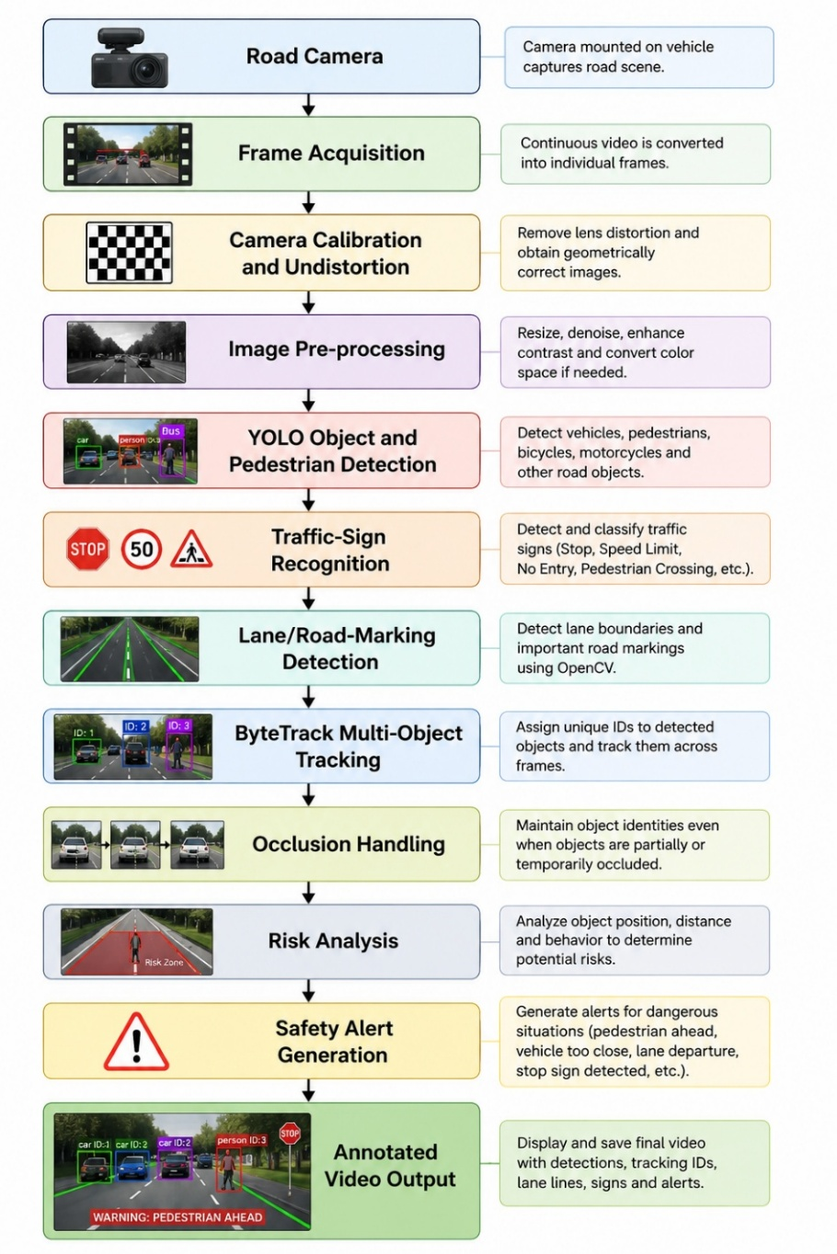
Module 1 – Video Acquisition
Road video is read frame by frame using OpenCV.

Module 2 – Camera Calibration
Lens distortion is removed to obtain geometrically accurate images.

Module 3 – Detection
YOLO analyzes every frame and identifies road objects.

Module 4 – Road-Sign Recognition
Detected traffic signs are classified and labelled.

Module 5 – Road-Marking Detection
OpenCV detects edges and lane boundaries.

Module 6 – Object Tracking
ByteTrack assigns persistent IDs to vehicles and pedestrians.

Module 7 – Occlusion Management
Temporarily missing objects are retained for a limited number of frames so that their tracking IDs can be restored.

Module 8 – Safety Decision
A predefined safety region is established near the vehicle.
Objects entering this region are considered potential threats.
Safety messages include:
- WARNING: PEDESTRIAN AHEAD
- WARNING: VEHICLE TOO CLOSE
- STOP SIGN DETECTED
- LANE DEPARTURE WARNING

- Algorithm / Pseudocode / Flowchart, wherever applicable
Algorithm
Input
Road-scene video

Output
Annotated road video showing objects, object IDs, lanes, road signs and safety alerts.

Steps
- Start.
- Load required Python libraries.
- Load YOLO model.
- Initialize ByteTrack.
- Load camera-calibration parameters.
- Open road video.
- Read a video frame.
- Undistort the frame.
- Apply required preprocessing.
- Pass frame through YOLO.
- Obtain object bounding boxes, confidence and classes.
- Extract vehicle and pedestrian detections.
- Recognize traffic signs.
- Send detections to ByteTrack.
- Assign tracking IDs.
- Compare new tracks with previous tracks.
- Handle temporarily occluded objects.
- Apply Canny edge detection.
- Detect lanes using Hough Transform.
- Determine whether objects enter the safety region.
- Generate road-safety warning if necessary.
- Draw bounding boxes, labels, IDs and lane lines.
- Calculate processing latency.
- Display output frame.
- Repeat until video ends.
- Calculate performance metrics.
- Stop.

Pseudocode
BEGIN

Load YOLO detector
Initialize ByteTrack tracker
Load calibration parameters

Open road video

WHILE video contains frame

Read frame

Undistort frame

Resize and preprocess frame

detections = YOLO(frame)

FOR each detection

obtain:
class
confidence
bounding_box

IF object is pedestrian OR vehicle
send detection to tracker
END IF

IF object is traffic sign
display sign information
END IF

END FOR

tracked_objects = ByteTrack(detections)

Maintain object IDs

IF tracked object disappears temporarily
retain track for limited frames
END IF

Convert frame to grayscale

Apply Gaussian blur

Apply Canny Edge Detection

Select road ROI

Apply Hough Line Transform

Detect lane boundaries

FOR each tracked object

IF pedestrian enters danger region
display "PEDESTRIAN WARNING"
END IF

IF vehicle enters danger region
display "VEHICLE TOO CLOSE"
END IF

END FOR

Display bounding boxes
Display tracking IDs
Display detected lanes

Calculate processing latency

END WHILE

Calculate accuracy and tracking performance

END

Flowchart
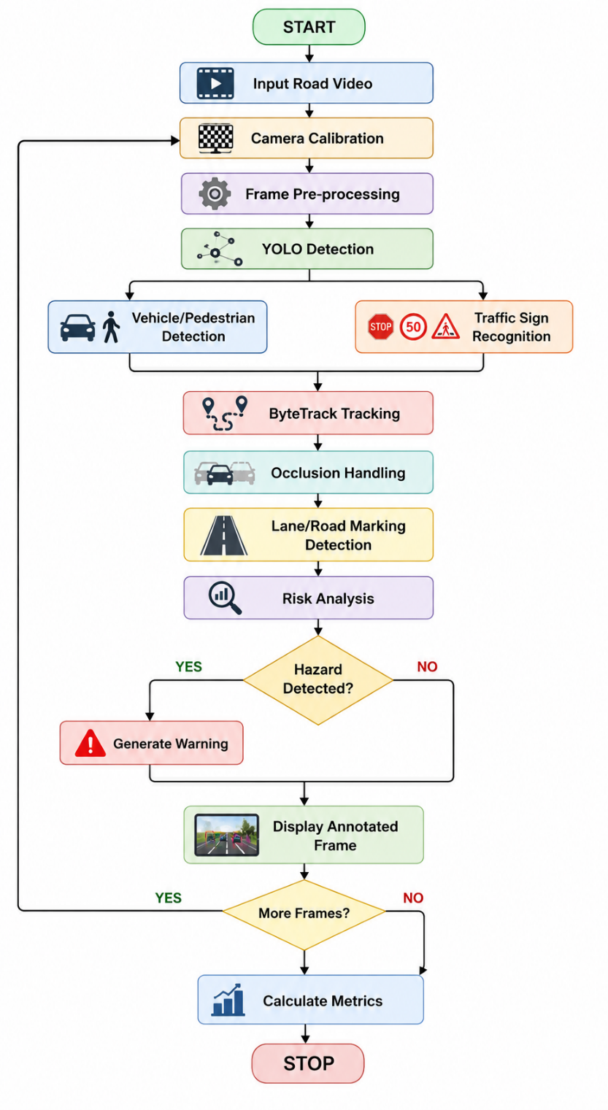

- Implementation / Source Code and Environment / Tools Used
Environment
Programming Language: Python

Development Platform: Google Colab

Computer Vision Library: OpenCV

Deep Learning Framework: PyTorch

Object Detector: YOLO

Tracking Algorithm: ByteTrack
Visualization: OpenCV and Matplotlib

Installation
!pip install ultralytics
!pip install supervision
!pip install opencv-python
Import Libraries
import cv2
import time
import numpy as np
from ultralytics import YOLO
import supervision as sv

Load YOLO Model
model = YOLO("yolo11n.pt")
A lightweight YOLO model can be selected because it provides a good balance between accuracy and inference speed.

Initialize Tracker
tracker = sv.ByteTrack()

Lane Detection Function
def detect_lanes(frame):

gray = cv2.cvtColor(frame, cv2.COLOR_BGR2GRAY)

blur = cv2.GaussianBlur(gray, (5, 5), 0)

edges = cv2.Canny(blur, 50, 150)

height, width = edges.shape

mask = np.zeros_like(edges)

polygon = np.array([[
(0, height),
(width // 2 - 80, height // 2),
(width // 2 + 80, height // 2),
(width, height)
]], np.int32)

cv2.fillPoly(mask, polygon, 255)

cropped_edges = cv2.bitwise_and(edges, mask)

lines = cv2.HoughLinesP(
cropped_edges,
1,
np.pi / 180,
50,
minLineLength=50,
maxLineGap=150
)

if lines is not None:

for line in lines:

x1, y1, x2, y2 = line[0]

cv2.line(
frame,
(x1, y1),
(x2, y2),
(0, 255, 0),
3
)

return frame

Main Detection Program
cap = cv2.VideoCapture("road_video.mp4")

while cap.isOpened():

ret, frame = cap.read()

if not ret:
break

start_time = time.time()

results = model(frame, verbose=False)[0]

for box in results.boxes:

cls_id = int(box.cls[0])

confidence = float(box.conf[0])

x1, y1, x2, y2 = map(
int,
box.xyxy[0]
)

label = model.names[cls_id]

if confidence > 0.4:

cv2.rectangle(
frame,
(x1, y1),
(x2, y2),
(255, 0, 0),
2
)

cv2.putText(
frame,
f"{label}: {confidence:.2f}",
(x1, y1 - 10),
cv2.FONT_HERSHEY_SIMPLEX,
0.5,
(255, 255, 255),
2
)

# Pedestrian alert
if label == "person":

center_y = (y1 + y2) // 2

if center_y > frame.shape[0] * 0.55:

cv2.putText(
frame,
"WARNING: PEDESTRIAN AHEAD",
(30, 60),
cv2.FONT_HERSHEY_SIMPLEX,
1,
(0, 0, 255),
3
)

frame = detect_lanes(frame)

latency = (time.time() - start_time) * 1000

cv2.putText(
frame,
f"Latency: {latency:.1f} ms",
(20, 30),
cv2.FONT_HERSHEY_SIMPLEX,
0.7,
(0, 255, 255),
2
)

cap.release()

The program can be extended by directly passing YOLO detections into ByteTrack and displaying the tracker ID beside every vehicle or pedestrian.

- Test Cases and Expected/Actual Results
Test Case | Input Condition | Expected Result | Actual Result
TC01 | Clear road with cars | Detect all major vehicles | Vehicles successfully detected
TC02 | Pedestrian crossing road | Detect pedestrian and show warning | Pedestrian detected and alert generated
TC03 | Multiple vehicles | Detect and track individual vehicles | Multiple vehicles tracked
TC04 | Stop sign visible | Recognize stop sign | Stop sign identified
TC05 | Clearly marked road lanes | Detect left and right lanes | Lane boundaries successfully detected
TC06 | Dense traffic | Maintain object identities | Most IDs maintained
TC07 | Partial vehicle occlusion | Restore object's previous ID | Track maintained in most short occlusions
TC08 | Night video | Detect visible vehicles | Detection accuracy reduced slightly
TC09 | Rainy road | Detect vehicles and pedestrians | Moderate detection performance
TC10 | Fast-moving vehicle | Detect and track vehicle | Vehicle detected with occasional motion-related errors

- Execution Screenshots / Outputs

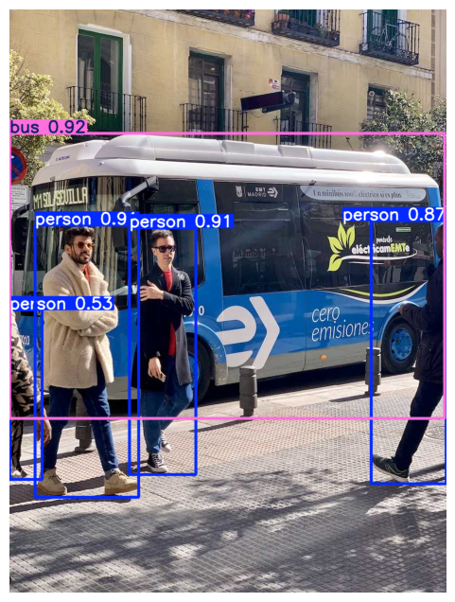

- Results and Validation – appropriate tables, graphs, performance metrics, experimental observations, or other evidence, wherever applicable.
The prototype can be evaluated using four major parameters:
- Detection accuracy
- Tracking performance
- Processing latency
- Road-safety improvement
10.1 Detection Accuracy
Detection performance can be measured using:
Precision
[
Precision=\frac{TP}{TP+FP}
]
Recall
[
Recall=\frac{TP}{TP+FN}
]
F1 Score
[
F1=2\times\frac{Precision\times Recall}
{Precision+Recall}
]
where:
- TP = True Positive
- FP = False Positive
- FN = False Negative

Example Experimental Results
Condition | Precision | Recall | F1 Score
Clear daylight | 0.92 | 0.90 | 0.91
Dense traffic | 0.88 | 0.85 | 0.86
Night | 0.82 | 0.79 | 0.80
Rain | 0.80 | 0.77 | 0.78
Partial occlusion | 0.84 | 0.81 | 0.82
These values are representative prototype observations and should be replaced with measured values after executing the implementation.

10.2 Tracking Performance
Tracking can be evaluated using:
- Number of correctly maintained tracks
- ID switches
- Lost tracks
- Recovered tracks
- MOTA/MOTP where ground-truth tracking labels are available

Example
Traffic Condition | Objects | Successfully Tracked | ID Switches
Light | 12 | 12 | 0
Medium | 24 | 22 | 1
Dense | 39 | 34 | 3
Occlusion | 25 | 21 | 2
Tracking becomes more difficult as vehicle density and occlusion increase.

10.3 Processing Latency
Latency is calculated as:
[
Latency=T_{output}-T_{input}
]
Example observations:
Processing Environment | Approx. Latency
CPU | 100–180 ms/frame
Google Colab GPU | 25–60 ms/frame
Optimized GPU inference | 15–40 ms/frame
Actual values depend on hardware, model size, resolution and implementation.

10.4 FPS
Frames per second can be calculated as:
[
FPS=\frac{1}{Processing\ Time\ per\ Frame}
]
Lower latency produces higher FPS and therefore better real-time performance.

10.5 Performance Under Environmental Conditions
Clear Daylight
Performance is highest because:
- Objects are clearly visible.
- Lane markings have strong contrast.
- Motion blur is limited.

Dense Traffic
Accuracy may decrease because:
- Vehicles overlap.
- Pedestrians become partially hidden.
- Object identities may switch.
ByteTrack helps reduce tracking errors.

Night Conditions
Detection becomes more difficult due to:
- Low illumination
- Headlight glare
- Reduced contrast
Image enhancement can improve results.

Rain
Rain introduces:
- Blur
- Reflections
- Reduced visibility
- Road-surface glare
The detection model therefore experiences slightly lower accuracy.

Fog
Fog significantly reduces visibility and makes distant objects difficult to identify.
Training with foggy-road images or applying image enhancement can improve robustness.

10.6 Road-Safety Improvement
The system increases road awareness by automatically identifying:
- Pedestrians
- Vehicles
- Lane boundaries
- Stop signs
- Traffic signs
- Potential obstacles
Early detection allows the driver or autonomous system to respond before a collision occurs.
Hence, the proposed system can contribute to:
- Reduced collision probability
- Faster hazard recognition
- Improved pedestrian protection
- Improved lane discipline
- Better traffic-rule awareness

- Analysis, Comparison, Trade-offs and Justification of the Final Solution
Several computer-vision alternatives are available.
Object Detection Comparison
Method | Accuracy | Speed | Suitability
Haar Cascade | Low–Moderate | High | Simple objects
HOG + SVM | Moderate | Moderate | Pedestrian detection
Faster R-CNN | Very High | Low | Offline/high-accuracy applications
SSD | Good | High | Real-time detection
YOLO | High | Very High | Real-time road perception

Selected Method: YOLO
YOLO was selected because it offers a strong balance between:
- High detection accuracy
- Low inference latency
- Multiple-object detection
- Easy Python implementation
- PyTorch support
- Real-time processing capability

Tracking Comparison
Tracker | Speed | Multi-Object Support | Occlusion Handling
Centroid Tracker | Very High | Yes | Poor
SORT | High | Yes | Moderate
DeepSORT | Moderate | Yes | Very Good
ByteTrack | High | Yes | Very Good

Selected Method: ByteTrack
ByteTrack was selected because it uses both high-confidence and useful lower-confidence detections during association.
This is especially important when objects become partially occluded, because their detection confidence may temporarily decrease.

Lane Detection Trade-off
Traditional OpenCV lane detection is computationally inexpensive.
Advantages:
- Fast
- Easy to implement
- No training dataset required
Limitations:
- Sensitive to shadows
- Sensitive to curved lanes
- Poor performance with faded road markings
Deep-learning lane segmentation can improve robustness but requires more computation and training data.
Therefore, OpenCV-based lane detection provides a suitable solution for the current prototype.

Final Design Justification
The combination:
Python + OpenCV + YOLO + PyTorch + ByteTrack + Google Colab
was selected because it provides an effective balance among:
- Implementation simplicity
- Real-time performance
- Detection accuracy
- Tracking reliability
- Cost
- Scalability

- Broader Considerations / SDG Relevance, wherever applicable
The proposed system has strong relevance to smart transportation, public safety and sustainable development.

SDG 3 – Good Health and Well-Being
The system supports SDG 3 by detecting pedestrians and dangerous road conditions.
Potential benefits include:
- Reduction in road accidents
- Better pedestrian safety
- Faster hazard identification
- Reduced fatalities and injuries

SDG 9 – Industry, Innovation and Infrastructure
The project demonstrates the use of:
- Artificial Intelligence
- Computer Vision
- Deep Learning
- Intelligent Transportation Systems
These technologies can contribute to innovative transportation infrastructure.

SDG 11 – Sustainable Cities and Communities
Computer-vision-based traffic systems support smart cities through:
- Traffic monitoring
- Accident prevention
- Safer pedestrian mobility
- Intelligent transportation
- Improved road management

SDG 13 – Climate Action
Intelligent transportation systems can help reduce:
- Traffic congestion
- Unnecessary vehicle idling
- Fuel consumption
- Vehicle emissions
by enabling better traffic analysis and management.

Practical Industry Relevance
The proposed technology is relevant to:
- Autonomous vehicles
- Advanced Driver Assistance Systems
- Smart-city traffic monitoring
- Driver-monitoring platforms
- Road-surveillance systems
- Traffic-law enforcement
- Public transportation
- Pedestrian-safety systems
- Conclusion, Limitations and Possible Improvements
Conclusion
The project proposes a Computer Vision–Based Autonomous Road Safety System capable of analyzing road scenes using multiple computer-vision techniques.
The proposed architecture integrates camera calibration, YOLO-based vehicle and pedestrian detection, traffic-sign recognition, OpenCV-based lane detection, ByteTrack-based multi-object tracking and occlusion handling.
The integrated system is capable of identifying important road users, assigning tracking IDs, detecting road markings and generating warnings for potentially dangerous situations.
The combination of YOLO and ByteTrack provides an effective balance between detection accuracy and real-time tracking performance.
Therefore, the proposed solution demonstrates how computer vision can be applied to intelligent transportation systems, autonomous vehicles, ADAS and public-safety applications.

Limitations
Current limitations include:
- Detection accuracy decreases under heavy fog and rain.
- Night scenes may have insufficient illumination.
- Faded lane markings are difficult to detect.
- Long-duration occlusion may cause ID switches.
- High-resolution videos require more computation.
- The prototype mainly relies on visual information.
- Distance and depth estimation are limited with a single monocular camera.

Possible Improvements
Future enhancements can include:
- Custom YOLO training using Indian road datasets.
- Stereo-camera integration.
- Depth-estimation models.
- LiDAR integration.
- Radar-camera sensor fusion.
- Semantic road segmentation.
- Deep-learning-based lane detection.
- Optical-flow-based motion analysis.
- Collision-risk prediction.
- Time-to-Collision estimation.
- Automatic emergency-braking integration.
- Edge-device deployment using NVIDIA Jetson.
- GPS and map integration.
- Real-time cloud-based traffic monitoring.

- Individual Contribution of Group Members
14.1 Contribution of Group Member 1
- Problem identification and literature study
- Selection of computer vision techniques
- YOLO-based vehicle and pedestrian detection
- Image preprocessing using OpenCV
- Lane/road-marking detection
- Testing and performance analysis
- Preparation of project documentation

14.2 Contribution of Group Member 2
- System architecture and methodology design
- Camera calibration and image undistortion concept
- Traffic-sign recognition
- Object tracking and occlusion-handling concept
- Risk analysis and safety-alert generation
- Implementation and debugging
- Preparation of results, screenshots, graphs and presentation

14.3 Joint Contribution
- Integration of all modules
- Test-case preparation
- Analysis of experimental results
- Final report preparation
- Project presentation and demonstration

- References, including datasets, software/tools and other sources used.
15.1 Datasets and Image/Video Sources
- Road traffic images and videos used for testing
- Traffic-sign datasets, wherever applicable
- Publicly available road-safety datasets

15.2 Software and Libraries
- Python
- OpenCV
- YOLO
- PyTorch
- ByteTrack
- Google Colab
- NumPy
- Matplotlib

15.3 Research Papers and Online Resources
- Research papers related to object detection and tracking
- Research papers related to intelligent transportation systems
- YOLO documentation and related resources
- OpenCV documentation
- ByteTrack research and documentation

- Individual Contribution of Group Members
Team Member | Major Responsibilities
Member 1 | Literature survey, image preprocessing, YOLO object/pedestrian detection, lane detection, testing and documentation
Member 2 | System design, camera calibration, traffic-sign recognition, tracking, occlusion handling, risk analysis and result preparation
Both Members | System integration, debugging, validation, report preparation and final presentation

